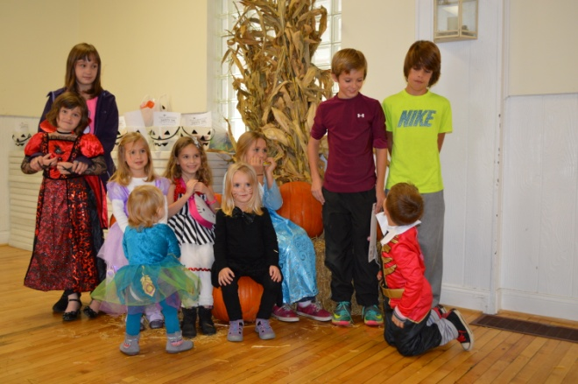
Kids Halloween Party Scheduled
Sunday, October 18th 1 pm until 3 pm
In need of wrapped candy, craft supplies, glue and plenty of volunteers
Signup sheet is in the club room. Please sign your kids up so we can have a count for activities. 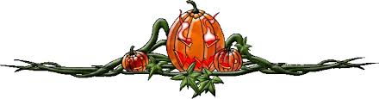
From the Commander’s Desk –
Kurtz Elementary located at 1350 Kurtz Dr., Milford has invited all Veterans to attend a special presentation on Nov 11th that will start with coffee and treats at 9AM with a
presentation at 9:30 AM. If your schedule permits please come out either in uniform or wearing legion apparel to be recognized for your service to our great nation. This is to be followed by an assembly at the Post at 10:15 with a departure time of 10:30 to walk to Milford Central Park for the unveiling of the monument. You can also meet us down

at the Park. This project was led by three individuals that energized the community in a Home front project to erect a monument. A very congratulatory “Well done”, to these Legionnaires; Ron Nevorski, Joe Bishop and Bear Hall. Milford has an everlasting symbol for those that have given the ultimate sacrifice.

You will be receiving via mail a solicitation to purchase a chance to win a $1,000 raffle. This raffle will be done only one time in a year in the future and will be sent out in the fall. Your consideration in this fund raiser is greatly appreciated.

Membership meeting is held every 3rd Tuesday of the month at 7:00 pm.
If you have any questions or comments concerning the Legion please contact Commander Rich Cherf at 248-974-9632 or cherfrgs@hotmail.com

Rich Cherf, Commander, Post 216
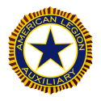

Auxiliary Chatter:

Membership dues can be paid online at the National website, www.alaforveterans.org.
Once on the site you will need to go to member login. Be prepared to enter in your membership number that is on your membership card. Follow the instructions on setting up an account and then follow for the payment information. Once you have paid print off your temp card and see Sally Morin for your actual card. This is to help get dues in faster and numbers to be more up to date. We would like to see 100 members paid by November 1st to be counted on reaching goal of 45% by November 11th.

Sponsoring Halloween Party on Saturday, October 17th from 7 pm until 12 am. Please get your tickets at the Clubroom for this fun night together. Tell your friends, tell your neighbors and reserve a table. Look for future details of what is needed shortly after our meeting on October 6th.

Next meeting will be October 6th @ 7 pm. We would love to see your smiling faces and hear your great ideas.

If you have any questions or comments concerning the Auxiliary please contact President Cathy Merritt at 248-770-0083 or merrittc64@gmail.com

Cathy Merritt President, Auxiliary Unit 216
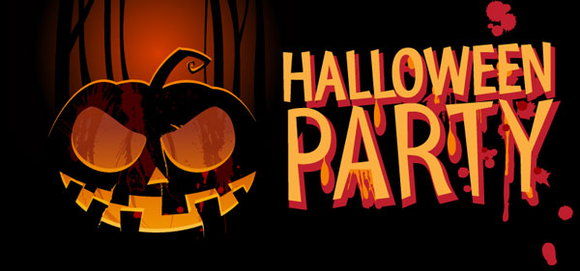

Sweetest Halloween Party –

Saturday, October 17th 7 pm to 12 am

$25 per person advance or $30 per person at door. Tickets available in the clubroom

Taco bar and beverages included

Featuring the band: Stompbox

Best Costume prize, 50/50, Raffles

Sponsored by: The American Legion Auxiliary Unit 216

See attached flyer

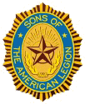
SAL Notes
The first, of many, Hamburger nights starts on Thursday Oct 1st and every Thursday after that. Times are from 5 pm until 8 pm.
Please come join us for monthly meeting’s the first Tuesday of every month at 7:30 pm in the club room.

If you have any questions or comments concerning the SAL please contact
Dan Scheideman at 248-767-8210 or
dan.scheideman@gmail.com

Dan Scheideman
SAL Commander

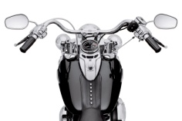

Behind the Handlebar’s

The Riders have two fund raisers for remodeling and making the club room
restrooms handicap accessible. The first is a spaghetti dinner Spaghetti Dinner Oct 10th 5-8 PM for $7.49. The second is selling bracelets for $5.00. This is a monumental task that has an estimated cost of $20K, the Riders have raised $5K for this project so far.

If you have any ideas or would like to contribute please contact any of the Riders.
Be watching for the announcement of the next Chili Cook-off.

If you have any questions or comments concerning the Riders please contact
Rich Cherf at 248-974-9632 or cherfrgs@hotmail.com

Rich Cherf
Director, ALR Post 216
Calendar – October
Thursday nights: Hamburger nights 5 pm until 8 pm
Friday nights: Bingo 6:30 pm
1st: Hamburger nights start
6th: Auxiliary 7 pm
6th: SAL 7:30 pm
10th: ALR Spaghetti Dinner 5pm-8pm
12th: ALR 7 pm
17th: Auxiliary Sweetest Halloween Party 7pm – 12 am
18th: Kids Halloween Party 1 pm – 3 pm
20th: Legion 7 pm
31st: Halloween
November
1st: 18th District Meeting 2 pm meeting post to be announced
3rd: Auxiliary 7 pm
3rd: SAL 7:30 pm
5th: Blood drive 2 pm – 7:45 pm
8th: 18th District Commanders Tour
9th: Riders 7 pm
17th: Legion 7 pm

Web sites:

Milford Post 216:
www.milfordlegion216.org

Department American Legion:
www.michiganlegion.org

Department American Legion Auxiliary:
www.michalaux.org

Nationals American Legion:
www.legion.org

Nationals American Legion Auxiliary:
www.alaforveterans.org

SAL
www.sal.legion.org

Milford American Legion Riders
www.milfordlegionriders.org

Michigan American Legion Riders
www.michiganlegion.org/legionriders

American Legion Riders
www.legion.org/riders
100th Centennial Page
www.legion.org/centennial

Facebook pages and/or groups:

American Legion Hall Post 216

ALA Unit 216, Milford MI – group under Cathy Coberley Merritt

Milford American Legion Riders
www.facebook.com/groups/MilfordLegionRiders

