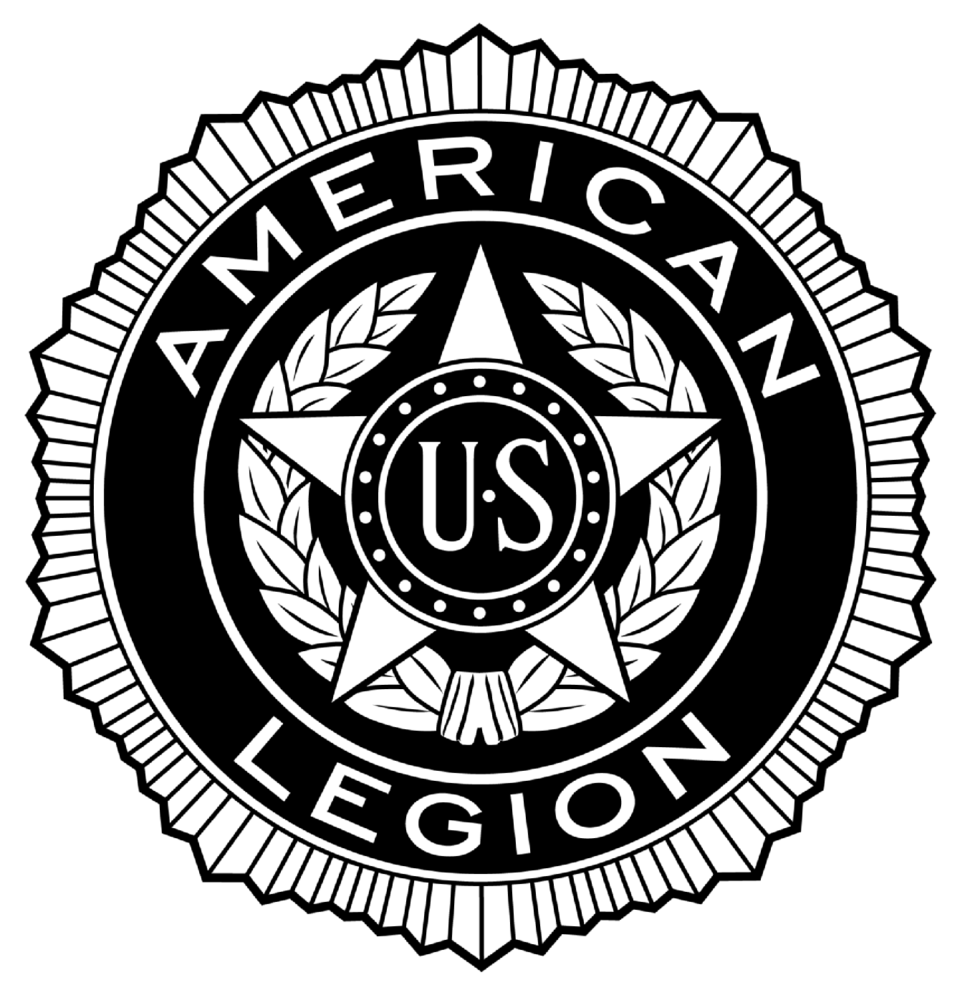
POST #216
Ernest F. Oldenburg, The American Legion
510 West Commerce Road, Milford, MI 48381
www.milfordlegion216.org

Adjutant Notes – Regular Membership Meeting – Milford POST 216

Commander Puente called the meeting to order at 19:05 Tuesday 17-September-2013

Opening Ceremonies observed.

ROLL CALL OF OFFICERS:
Title | Name | Present | Excused | Absent
Commander | Tony Puente | X
Senior Vice Commander | Norm Tibbs | X
Junior Vice Commander | Bill Colegrove | X
Adjutant | Dennis Dobransky | X
Finance Officer | Ray Williams |  | X
Chaplain | Ed Merritt | X
Historian | Ivan Emiline |  | X
Sergeant-at-Arms | Denny Lloyd |  | X
Exec. Committee | Don Reddeman | X
Exec. Committee | Jack Winder | X
Exec. Committee | Matt Tibbs | X
Exec. Committee Aux | Cathy Merritt | X
Exec. Committee SAL | Butch Maxwell |  | X

Approval of Minutes: Review of Regular Membership minutes from 20 August, 2013. Motion by Reddeman to accept, Second by Winder. No discussion. Voice Vote passes.

Guests: Matt Tibbs for Lloyd. Cathy Merritt, Aux; Jennifer Ricketts, SAL; Michelle Balser, and Sam Khaleghi.

Motion to suspend regular meeting for special guest presentations. Robinson first, Moore second. No discussion. Motion passes.

Commander Puente presented a Certificate of Appreciation to Jennifer Ricketts for the Post rummage sale, that earned for the Post $1,376 net of expenses.

Commander Puente introduced Michelle Balser, and Sam Khaleghi for their movie, Approaching Midnight, and the movie premiere at Emagine Theatre in Royal Oak, and presented a Certificate of Appreciation to both. Sam Khaleghi let us know of his appreciation to have been a part of the movie to include Post 216. He then presented the Post with a check for monies raised at the movie premiere in the amount of $1,863.75.
(1)
POST #216
Ernest F. Oldenburg, The American Legion
510 West Commerce Road, Milford, MI 48381
www.milfordlegion216.org

Motion made to resume regular meeting. First Reddeman, Second Robinson. No discussion. Voice vote passes.

Reports of Officers:

Sr. Vice Commander: N. Tibbs. No report.
Jr. Vice Commander: Colegrove. Legion picnic cost $706, donations and 50/50 brought in $399 for a net cost of $308, to be shared equally by the Post, SAL, ALR and Aux of $102 each. All in attendance had a great time.
Finance Officer: Dobransky for Williams. Income for August was $43,752; cost of goods $23,052; gross profit $12,990; expenses $10,773; net income $2,217. General fund balance of $4,216, less bills due of $604. First to accept report Reddeman; Second Merritt. No discussion. Voice vote passes.
Chaplain: Merritt. This past month we lost Jerry Savitsky who passed away. Sick call: Ray Lapine, Legion; Jeff Temples, SAL; Pat Dowd, SAL; Dave Horst, Legion; and Denny Lloyd, Legion. Also, a prayer for the 14 Navy personnel killed at the Washington D.C. area Naval yard. Also, September 18 is the U.S Air Force 66th birthday. September 21 is POW/MIA recognition day.
Service Officer: Reddeman. No report.
Historian: Emiline. No report.
Adjutant: Dobransky. Reminded Membership of upcoming District 18 tour to Post 216. Our Post will provide a lunch for the tour.
Auxiliary: Cathy Merritt: No report.
SAL: McDonnell for Maxwell. Hamburger night starts the 1st Thursday of October to be held each Thursday of the month.

Committee Reports:

Membership: Kotas. No new members to report. Current membership is at 398 and may hit 400 with new transfers. Our goal is 386 members.
Veterans Honors, Ceremonial:
Color Guard: Robinson. No report.
Honor Guard: Dobransky for Chowaniec. 7 services at Great Lakes, and one locally.
Poppy: Reddeman. No report.
Honor Walk: Puente. The supplier account was shut down due to paperwork issue, but has been corrected and bricks to be picked up.

(2)
POST #216
Ernest F. Oldenburg, The American Legion
510 West Commerce Road, Milford, MI 48381
www.milfordlegion216.org

Memorial Day Parade: Salvia. No report.
Education and Scholarship: Davison. Absent. No report.
Bingo: McDonnell. Gross Bingo $10,931; Gross Tickets $14,487; Ticket prizes $10,782; Bingo prizes $7,624; Gross profit $6,700; Expenses $3,000; To Legion $2,000; Ending check book balance $$2,825. Motion Neff, Second Winder. Discussion. Need help with Bingo nights. Voice vote passes.
Club Room: McDonnell. Gross income $10,495; Cost of goods $3,861; Gross Profit $6,638; $5,051; Net Income $1,578; Check to Legion for $1,000. Motion to accept: First Reddeman, Second Bonnie. No discussion. Voice vote passes.
Charitable Gaming Tickets: McDonnell. Beginning balance $1,492; ending balance $1,210; check to Legion for $1,000. Motion to accept: First Moore, Second Merritt. No discussion. Voice vote passes.
American Legion Riders: Dobransky for Paul Kolleda. Some ALR members went to Trail of Tears ride. Cider run scheduled for October 6 to St. Johns cider mill.
House & Building: Puente. Sprinklers scheduled for winterization in October. The new gazebo is now open and looks great. Norm Tibbs advised of Gary Couzins engraving a plaque on the tank out front.
Executive Committee: Reviewed Executive Committee minutes for August 20, 2013. Motion to accept. First, Reddeman, Second, Winder. No discussion. Voice vote passes.
Unfinished Business: No report.
New Business: Correspondence: Dobransky. Wolverine Lake packing for packages going to troops and military dogs looking for volunteers for October 12, 2013. Also, Heartland Hospice is providing a day for veterans to honor our veterans on November 7, flyer in Club Room. A note of thank you from Milford class of 1978 has their reunion and appreciated the use of the hall and to Butch Maxwell for his services.
Merritt. Received a letter from the family of Jerry Savitsky expressing appreciation for the Honor Guard’s presence at the Milford cemetery, and his presence at the funeral home.
Good of the Legion: Joe Bishop brought up the existing trailer at Great Lakes Cemetery, used by the Honor Guard, that is in need of maintenance. Proposed the Post agree to spend up to $250 to do the needed work, to be coordinated by Rich Chowaniec. First Bishop, Second N. Tibbs. No discussion. Voice vote passes.

(3)
POST #216
Ernest F. Oldenburg, The American Legion
510 West Commerce Road, Milford, MI 48381
www.milfordlegion216.org

Thomas Neff brought to the attention of Membership his review of the By-Laws suggested for changes and presented to the Executive Committee. Recommended changes to be issued to Membership for review.
Merritt. Advises he sits on the board for the 18th District for the American Legion and was informed that to date there are 18,786 veterans interned at Great Lakes Cemetery. On September 28, there is a clean-up for the fall to clean head stones and looking for volunteers to assist. Also, he is going to the fall conference and is seeking assistance for the lodging and mileage expenses, up to $300. First N. Tibbs, Second Reddeman. No discussion. Voice vote passes.
Closing: Commander Puente: There being no further business to come before the membership the meeting was adjourned at 20:00, with the proper closing ceremonies being observed.

The next meeting is 15 October, 2013, 19:00.

Prepared and submitted by: Dennis Dobransky, Adjutant

(4)
POST #216
Ernest F. Oldenburg, The American Legion
510 West Commerce Road, Milford, MI 48381
www.milfordlegion216.org

Adjutant Notes – Executive Committee Meeting – Milford POST 216

Commander Puente called the meeting to order at 18:10 Tuesday 17-September-2013.

Opening Ceremonies observed.

ROLL CALL OF MEMBERS:
Title | Name | Present | Excused | Absent
Commander | Tony Puente | X
Senior Vice Commander | Norm Tibbs | X
Junior Vice Commander | Bill Colegrove | X
Adjutant | Dennis Dobransky | X
Finance Officer | Ray Williams |  | X
Chaplain | Ed Merritt | X
Historian | Ivan Emiline | X
Sergeant-at-Arms | Denny Lloyd |  | X
Exec. Committee | Don Reddeman | X
Exec. Committee | Jack Winder | X
Exec. Committee | Matt Tibbs | X
Exec. Committee Aux | Cathy Merritt | X
Exec. Committee SAL | Butch Maxwell |  | X

Old Business: Judy from our CPA office advised we do not need to do an external audit, as our internal Post audit is sufficient, coupled with their review of our monthly financial activities.

Norm Tibbs looking for U.S. flags made in the USA vs. from overseas. Ed Merritt knows of a supplier in Clawson he is going to pursue.

New Business: Norm Tibbs mentioned new IRS guidelines that perhaps a CPA needs to review. Commander Puente to give info to our CPA and provide an update at next meeting.

Dobransky mentioned email sent to the District regarding upcoming tour, waiting on when they will visit our Post. We may need to provide a lunch based on the current schedule of 11:30am. Will have to present to Membership to allow up to $300 for a District tour lunch.

Bill Colegrove advised cost of picnic was $706, and monies received back was $399 from 50/50 and donations, so net cost was $308. SAL, ALR and Aux may contribute $102 each toward the net cost.

(1)
POST #216
Ernest F. Oldenburg, The American Legion
510 West Commerce Road, Milford, MI 48381
www.milfordlegion216.org

Dobransky mentioned the internal Post audit results that need to be submitted to State. Will obtain signatures on the required form.

Thomas Neff, Post Judge Advocate, presented suggested By-Laws changes that will then need to be presented to Membership. Norm Tibbs suggested that a By-laws committee be formed to review the proposed changes to then be presented to Executive Board before being presented to Membership. Commander Puente suggested presenting grammatical changes to Membership, then do a complete review and change presentation to Membership afterward. Mr. Neff offered to donate the cost for postage to do the mass mailing to Membership when the proposed By-Law changes are issued to Membership.

Commander Puente to ask Membership to cover costs for Ed Merritt to attend fall conference, as a member of the Post.

Motion to adjourn Reddeman, Second Emiline. No discussion. Voice vote passes. The meeting ended at 18:55.

The next meeting is 15 October, 2013, 18:00.

Prepared and submitted by: Dennis Dobransky, Adjutant

(2)

