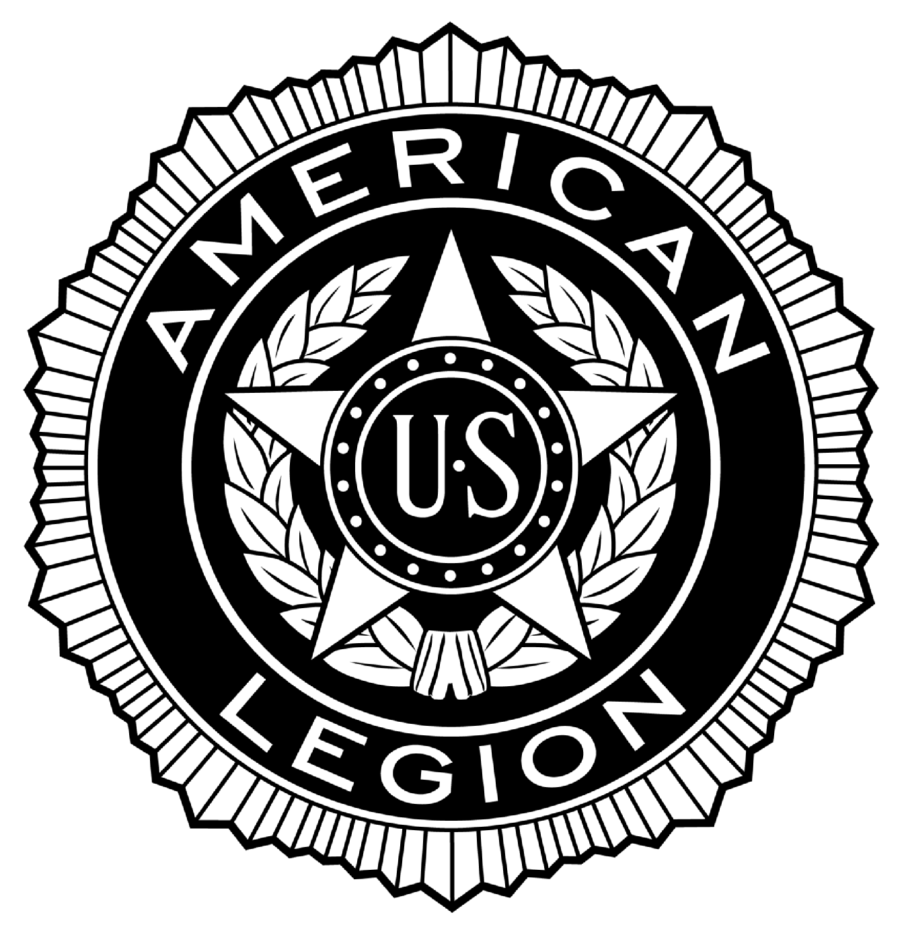
POST #216
Ernest F. Oldenburg, The American Legion
510 West Commerce Road, Milford, MI 48381
www.milfordlegion216.org

Adjutant Notes – Regular Membership Meeting – Milford POST 216

Commander Puente called the meeting to order at 19:00 Tuesday 19-November-2013

Opening Ceremonies observed.

ROLL CALL OF OFFICERS:
Title | Name | Present | Excused | Absent
Commander | Tony Puente | X
Senior Vice Commander | Norm Tibbs | X
Junior Vice Commander | Bill Colegrove | X
Adjutant | Dennis Dobransky | X
Finance Officer | Ray Williams | X
Chaplain | Ed Merritt | X
Historian | Ivan Emiline | X
Sergeant-at-Arms | Denny Lloyd |  | X
Exec. Committee | Don Reddeman | X
Exec. Committee | Jack Winder | X
Exec. Committee | Matt Tibbs | X
Exec. Committee Aux | Cathy Merritt | X
Exec. Committee SAL | Butch Maxwell | X

Guests: Cathy Merritt, Auxiliary. Butch Maxwell, SAL. Pharmacist Dave from CVS.

Approval of Minutes: Review of Regular Membership minutes from 15 October, 2013. Motion by Reddeman to accept, Second by Winder. No discussion. Voice Vote passes.

Motion to suspend regular meeting by Merritt, Second by Reddeman, to have Pharmacist Dave present to the membership. Voice Vote passes.

Pharmacist Dave advised membership he is providing free flu shots in the Club Room following the meeting.

Motion to resume regular meeting by Reddeman, Second by Merritt. Voice vote passes.

Reports of Officers:

Sr. Vice Commander: N. Tibbs. No report.
Jr. Vice Commander: Colegrove. No report.
(1)
POST #216
Ernest F. Oldenburg, The American Legion
510 West Commerce Road, Milford, MI 48381
www.milfordlegion216.org

Finance Officer: Williams. No report. Our CPA is still working on October reports, so Williams will present the October report next month.
Chaplain: Merritt. Continued prayers for family of Richard Krolicki, Korean War veteran, U.S. Army. Sick call: Dave Horst, Legion; Pat Dowd, SAL; Denny Lloyd, Legion; Ray Lapine, Legion; Brian Hamilton, SAL; Kandy Guest, Aux; Madeline Labbe, Aux; Jan LaClair, Aux; Scott Hungerford, Legion; and Marie Jackson, Aux.
Service Officer: Reddeman. No report.
Historian: Emiline. No report.
Adjutant: Dobransky. Read a note of thank you from Wilwin Lodge for our donation of $180. Read note of thank you from the Paralyzed Veterans of America posting colors at the 10th annual Salute to Veterans gala.
Auxiliary: Cathy Merritt: Kids Christmas party on Saturday, December 7, from 12:00 to 14:00. Needs help setting up and taking down chairs, tables, etc. Auxiliary members to assist at Bingo this Friday.
SAL: Maxwell. Burger night is every Thursday evening. Also, SAL Christmas party is on December 14, at 13:00, Legion members are invited.

Committee Reports:

Membership: Dobransky for Kotas. As of November 18, 2013, 269 members have renewed for 2014, with a Department goal of 75% by December 9, 2013. We are currently at 70% of goal.
Matthew R. Brown, Gulf War, U.S. Marines (4) years, and U.S. Army (1) year. Motion to accept into membership by Dobransky. First Colegrove, Second Reddeman. No discussion, voice vote passes.
Veterans Honors, Ceremonial:
Color Guard: Commander Puente advised the Guard went to Kurts Elementary on Veterans Day; Participated in Colors at both Lakeland and Milford high schools; and presented Colors at Paralyzed Veterans of America 10th annual gala.
Honor Guard: Chowaniec. 11 services at Great Lakes National Cemetery; Honors at a funeral home for a U.S. Air Force veteran; Honors at St. Mary’s Catholic church for a U.S. Navy veteran; and a silent watch at a funeral home for a U.S. Army veteran.
Poppy: Reddeman. Was able to assist one distressed veteran this month.
Honor Walk: Puente. Account with Unilock has been renewed.
Memorial Day Parade: Salvia. No report.
Education and Scholarship: Maxwell. No report.
Bingo: Commander Puente advised he did not complete a report that is a big part of our monthly financial report, thus the reason why the October report was not completed on time for this meeting. However, Bingo is doing well, and has been assisted by the American Legion Riders. The progressive jackpot is in excess of $2,300. Always looking for volunteers to assist with Bingo.

(2)
POST #216
Ernest F. Oldenburg, The American Legion
510 West Commerce Road, Milford, MI 48381
www.milfordlegion216.org

Club Room: Morin for McDonnell. Income $8,383; Cost of Goods Sold $3,016; Gross Profit $314; Expenses $5,786; Net Loss ($472). Note several bills paid this past month to include Workers Compensation Insurance $861; Taxes over $200; and accountant $875, thus reason for the net loss. Motion to accept Reddeman, Second Merritt. No discussion. Voice Vote passes.
Charitable Gaming Tickets: McDonnell. Absent, no report.
American Legion Riders: Dobransky for Kolleda. Riding season is over. Williams advised of ALR Christmas party on December 13. Dobransky advised of an upcoming brat night, the night to be determined. Also, Commander Puente gave appreciation for the assistance of Paul Kolleda and Rich Cherf assisting with Bingo for a few weeks, and well as Liz Kolleda. Thank you to the Riders for their support.
House & Building: N. Tibbs. Advised Matt Tibbs replaced the lights in the parking lot. Also, the carpet in the foyer and stairs need to be cleaned. Motion to spend $150 to clean the carpet. Second Emiline. No discussion. Voice vote passes.
Executive Committee: Reviewed Executive Committee minutes for October 15, 2013. Motion to accept. First, Winder, Second, Merritt. Discussion: Dobransky advised the Executive Board had authorized up to $300 for the Commanders tour with $100 for the bus and $200 for food, but the food was donated, so the $200 was not spent. Total cost for the tour was only $100. Voice vote passes.
Unfinished Business: Dobransky. No report.
New Business: Merritt. Advised he is the 18th District Chaplain. He received a notification from Great Lakes National Cemetery that on December 14, they are hosting Race Across America. Start time is 10:30. Wreath laying at 11:00, and formal ceremony at 12:00. Also, making a motion to obtain Blue Star flags for $182.75, and would like to purchase the flags to be made available to active service members. Second Emiline. No discussion. Voice Vote passes.
Good of the Legion: N. Tibbs. Made motion for the Post to purchase Officer Guides for all Post officers. Second, Moore. Discussion: Commander Puente advises the cost is $12 plus shipping and there are (6) officers that would require the guide. Voice vote passes.
# - N. Tibbs asked that it be posted on a calendar when the hall is being rented out. B. Maxwell to look into this.
# - B. Maxwell advises he is the leading candidate for Detachment Commander of SAL, and is asking for a letter of support from the Post. Second, N. Tibbs. No discussion. Voice vote passes.
# - Chowaniec advises the branch and national colors flags, used by the Color Guard, require cleaning. Can the Color Guard obtain funds for cleaning and sleeves. Commander Puente suggested just buying new flags. Will discuss after the meeting.

Closing: Commander Puente: There being no further business to come before the membership the meeting was adjourned at 18:40, with the proper closing ceremonies being observed.

The next meeting is 17 December, 2013, 18:40.

Prepared and submitted by: Dennis Dobransky, Adjutant

(3)
POST #216
Ernest F. Oldenburg, The American Legion
510 West Commerce Road, Milford, MI 48381
www.milfordlegion216.org

Adjutant Notes – Executive Committee Meeting – Milford POST 216

Commander Puente called the meeting to order at 18:05 Tuesday 19-November-2013.

Opening Ceremonies observed.

ROLL CALL OF MEMBERS:
Title | Name | Present | Excused | Absent
Commander | Tony Puente | X
Senior Vice Commander | Norm Tibbs | X
Junior Vice Commander | Bill Colegrove | X
Adjutant | Dennis Dobransky | X
Finance Officer | Ray Williams | X
Chaplain | Ed Merritt | X
Historian | Ivan Emiline | X
Sergeant-at-Arms | Denny Lloyd |  | X
Exec. Committee | Don Reddeman | X
Exec. Committee | Jack Winder | X
Exec. Committee | Matt Tibbs | X
Exec. Committee Aux | Cathy Merritt | X
Exec. Committee SAL | Butch Maxwell |  |  | X

Approval of Minutes: Review of Executive Committee minutes from 15 October, 2013. Motion by Reddeman to accept, Second by Emiline. No discussion. Voice Vote passes.

Old Business: Commander Puente working on By-Law updates – to be completed by December meeting.

Commanders tour was allocated $300, with $100 toward the cost of the bus, and $200 for food. However, the food was donated, so net cost of the tour to the Post was only $100.

New Business: The Post purchased a new computer for $550.

Norm Tibbs advised of the upcoming luncheon to be held on December 7, 2013, for area WWII veterans.

Norm Tibbs brought up a concern that the Club Room was closing at times before the posted closing time. Says that the Club Room should remain open until the posted closing time. (Someone) stated the Club Room closes early if there are not enough people present making purchases to maintain the

(1)
POST #216
Ernest F. Oldenburg, The American Legion
510 West Commerce Road, Milford, MI 48381
www.milfordlegion216.org

expense of keeping the Club Room open. It is currently at the discretion of the Club Room manager to decide to close early. Motion made to keep the Club Room open until the posted closing time, regardless of the number of people present. Voice Vote is (4) yes, and (4) no. Commander Puente cast the deciding vote to close the Club Room before posted hours if there are not enough people to justify keeping the Club Room open. Motion fails.

Dobransky read correspondence from Southwest Solutions asking for cash donation of any amount to support the Piquette Square for Veterans complex in Detroit, to aid with homeless veterans. Dobransky made a motion to provide a donation. Voice Vote had only (1) yes. Motion fails.

Williams advises our accountant did not provide financial reports, so no report this month. Will update October results at the next meeting.

Motion to adjourn meeting by Reddeman, Second Colegrove. Voice vote passes. The meeting ended at 18:50.

The next meeting is 17 December, 2013, 18:00.

Prepared and submitted by: Dennis Dobransky, Adjutant

(2)

