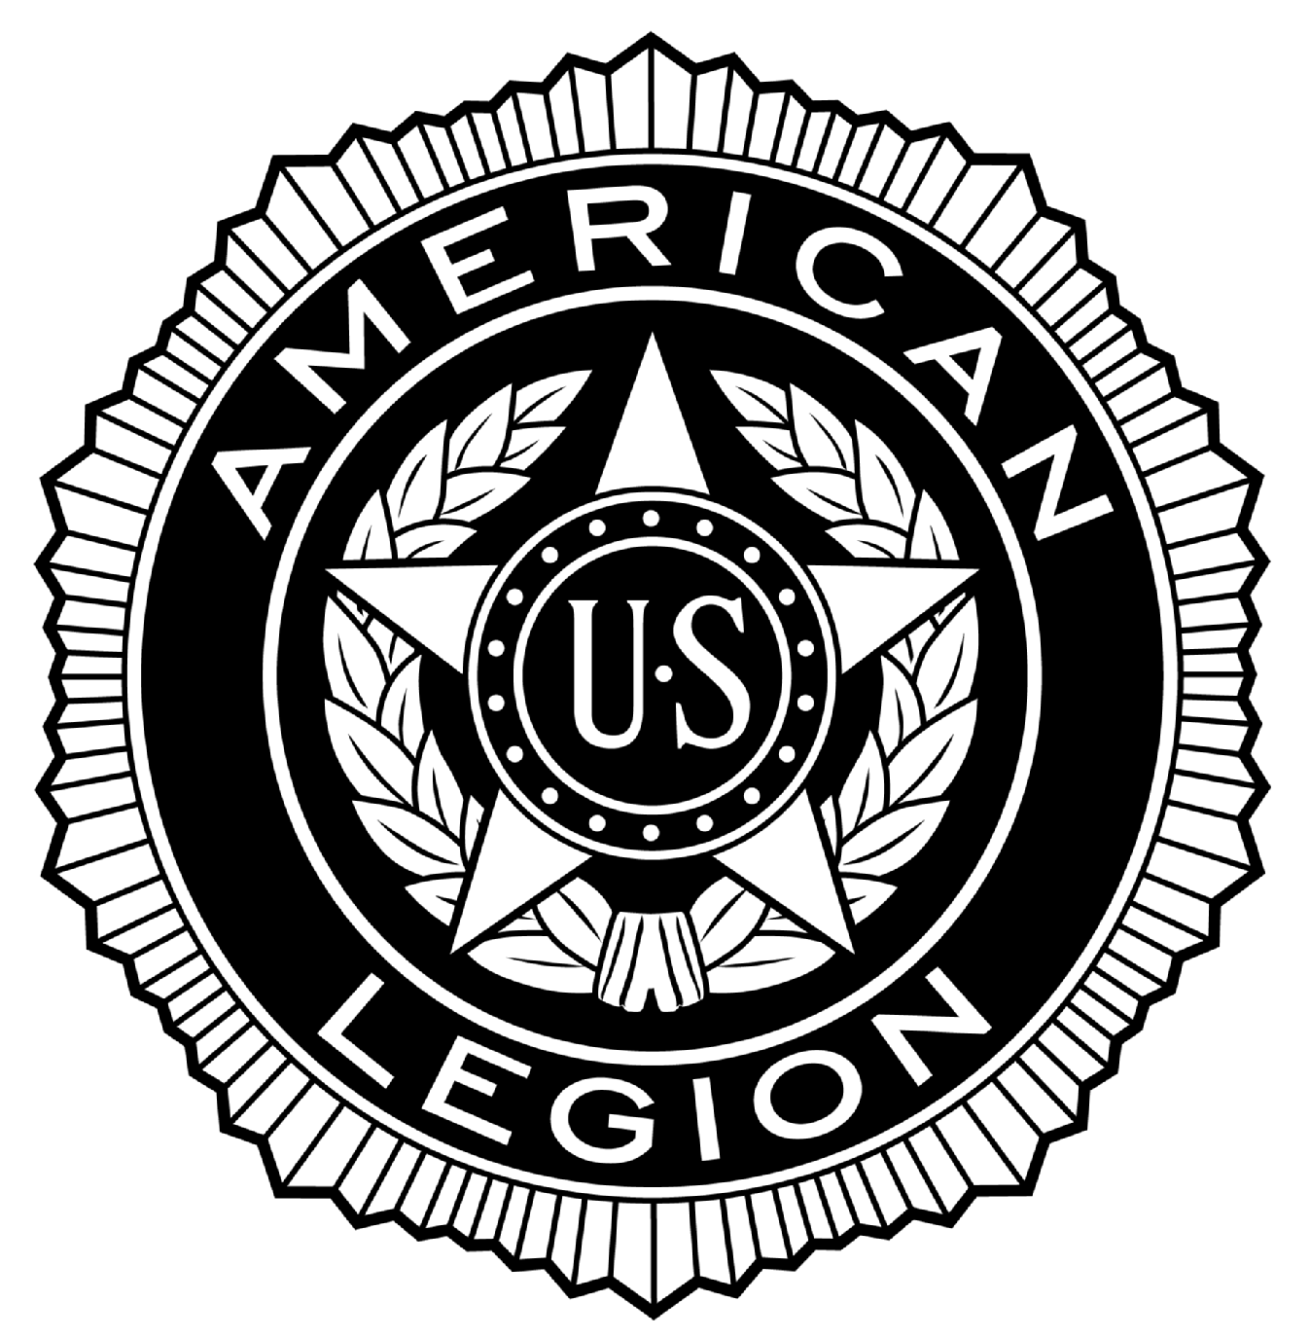
POST #216
Ernest F. Oldenburg, The American Legion
510 West Commerce Road, Milford, MI 48381
www.milfordlegion216.org

Adjutant Notes – Regular Membership Meeting – Milford POST 216

Commander Puente called the meeting to order at 19:05 Tuesday 18-February-2014

Opening Ceremonies observed.

ROLL CALL OF OFFICERS:
Title | Name | Present | Excused | Absent
Commander | Tony Puente | X
Senior Vice Commander | Norm Tibbs | X
Junior Vice Commander | Bill Colegrove | X
Adjutant | Dennis Dobransky | X
Finance Officer | Ray Williams |  | X
Chaplain | Ed Merritt | X
Historian | Ivan Emiline |  | X
Sergeant-at-Arms | Denny Lloyd | X
Exec. Committee | Don Reddeman |  | X
Exec. Committee | Jack Winder | X
Exec. Committee | Matt Tibbs | X
Exec. Committee Aux | Cathy Merritt | X
Exec. Committee SAL | Butch Maxwell |  | X

Guests: Cathy Merritt, Auxiliary. Rich Cherf, Legion.

Approval of Minutes: Review of Regular Membership minutes from 21 January, 2014. Motion by E. Merritt to accept, Second by Winder. Discussion: N. Tibbs says to correct under Poppy, add No Report after Reddeman. Voice Vote passes.

Reports of Officers:

Sr. Vice Commander: N. Tibbs. No report.
Jr. Vice Commander: Colegrove. No report.
Finance Officer: Dobransky for Williams. January report: General Fund balance is $8,288.23. All bills paid to date for February. Special Fund balance is $4,147.64. The Bank of America loan balance is $5,182.91. Motion by Neff, Second by B. Welbaum. No discussion. Voice vote passes.

(1)
POST #216
Ernest F. Oldenburg, The American Legion
510 West Commerce Road, Milford, MI 48381
www.milfordlegion216.org

Chaplain: Merritt. Continued prayers for the family of George Gates, Legion. Also, 18th District Chaplain E. Ray Johnston. Continued prayers for speedy recovery from sick call: Dave Horst, Legion; Pat Dowd, SAL; Ray Lapine, Legion; Brian Hamilton, SAL; Paul Lear, Legion; and Scott Hungerford, Legion.
Service Officer: Commander Puente for Reddeman. Helped a spouse for a deceased member with an electric bill.
Historian: Emiline. Excused. No report.
Adjutant: Dobransky. No report.
Auxiliary: Cathy Merritt: Advised the Auxiliary assisted at Bingo. Honor Guard lunches to be provided. A Blue Star flag was presented to Bob & Stacie Zukowski. Also, Auxiliary membership is at 100%. Also, Junior conference to be held at the Post on April 5 and 6, and help is appreciated to help with 50 girls.
SAL: Maxwell. Excused. No report.

Committee Reports:

Membership: Kotas. Post has 349 paid members so far for 2014, membership goal for 2014 is 386, and at this time we are at 90% of the goal for 2014.
New Members: Roberta M. Desmond, Air Force, Vietnam. Motion to accept M. Tibbs, Second B. Welbaum. No discussion. Voice vote passes.
Veterans Honors, Ceremonial:
Color Guard: Commander Puente – No report, but we do need a Commander.
Honor Guard: Chowaniec. Honors provided for (6) veterans at Great Lakes National Cemetery. Also, honors for (2) local veterans. Also, a $100 donation from the VFW.
Poppy: Reddeman. No report.
Honor Walk: Davison. No report.
Memorial Day Parade: Salvia. Asked if he will continue as chairman. Commander Puente advised to be taken up with the Executive Committee.
Education and Scholarship: Skip Davison advises applications are being submitted by Lakeland and Milford high schools.
Bingo: McDonnell. January: Gross Bingo $8,532; Gross tickets $11,067; Ticket prizes $8,234; Bingo prizes $6,187; Gross Profit $5,030. Deposit tickets $2,833; Deposit Bingo $2,095; Ending balance $1,259. $1,800 to Legion. Ending check book balance $2,715. Motion to accept Winder, Second Chowaniec. No discussion. Voice Vote passes. For the year 2013, Bingo turned over to the Post $27,690.

(2)
POST #216
Ernest F. Oldenburg, The American Legion
510 West Commerce Road, Milford, MI 48381
www.milfordlegion216.org

Club Room: McDonnell. Income $6,757 – lowest month in over 15 years. Cost of Goods Sold $2,816; Gross Profit $3,963; Expenses $4,445; Net Loss ($488). Motion to accept, First Winder, Second B. Welbaum. No discussion. Voice Vote passes.
Charitable Gaming Tickets: McDonnell. Ending check book balance $1,042. Ending check book balance $966; Gaming tickets contributed $1,000 to Legion. Motion to accept Lloyd, second Kolleda.
American Legion Riders: Kolleda. Presented to the Post the ALR is going to run a raffle to raise funds for rest room renovations. Cash prize of $500 unless not enough money is raised, would then convert to a 50/50 drawing. Drawings to be held on July 4 and again on November 1. First ALR meeting for 2014 to be held on March 10.
House & Building: N. Tibbs. Locks replaced on flag pole. Some lights replaced with LED bulbs in the Club Room. An energy audit report has been provided to the Post, to be discussed further at the next meeting..
Executive Committee: Reviewed Executive Committee minutes for January 21, 2014. Motion to accept. First, Kolleda, Second, B. Welbaum.
Unfinished Business: Dobransky. No report.
New Business: Dobransky. No report. Chaplain Merritt advised if any member has family members that may be interested in the Boys State program to let him know. Also, it is Post 216’s 89th birthday. Celebrating Americanism at the American Legion this month.
Good of the Legion: Discussion about record keeping of DD214’s, and if any member is approached about former members’ DD214’s, then bring it to the attention of the Post Commander or the Adjutant so we can then contact the Membership Committee chairperson. R. Chowaniec asked how we go about finding how many veterans are buried in Milford Memorial, so flags may be provided. Commander Puente presented fish fry sales information, after expenses a carry-over profit of $151.92. Fish Fry to run for the next (8) weeks. Also, Laughs at the Legion to be held on March 1, with Post making money off of food sales and cash bar. Post makes about $1,200. N. Tibbs advised that the Knights of Columbus would like to park their trailer next to the Boy Scout trailer in the parking lot. Motion by R. Chowaniec, second, B. Welbaum. Discussion: T. Neff suggested we ensure the trailer is insured for theft. Voice vote passes.
Closing: Commander Puente: There being no further business to come before the membership the meeting was adjourned at 19:55, with the proper closing ceremonies being observed.

The next meeting is 18 March, 2014, 19:00.

Prepared and submitted by: Dennis Dobransky, Adjutant

(3)
POST #216
Ernest F. Oldenburg, The American Legion
510 West Commerce Road, Milford, MI 48381
www.milfordlegion216.org

Adjutant Notes – Executive Committee Meeting – Milford POST 216

Commander Puente called the meeting to order at 18:00 Tuesday 18-February-2014.

Opening Ceremonies observed.

ROLL CALL OF MEMBERS:
Title | Name | Present | Excused | Absent
Commander | Tony Puente | X
Senior Vice Commander | Norm Tibbs | X
Junior Vice Commander | Bill Colegrove | X
Adjutant | Dennis Dobransky | X
Finance Officer | Ray Williams |  | X
Chaplain | Ed Merritt | X
Historian | Ivan Emiline |  | X
Sergeant-at-Arms | Denny Lloyd | X
Exec. Committee | Don Reddeman |  | X
Exec. Committee | Jack Winder | X
Exec. Committee | Matt Tibbs | X
Exec. Committee Aux | Cathy Merritt | X
Exec. Committee SAL | Butch Maxwell |  | X

Approval of Minutes: Review of Executive Committee minutes from 21 January, 2014. Motion by Lloyd to accept, Second Merritt. Correction: Change Chris Walker to Walters, SAL. Voice Vote passes.

Old Business: Commander Puente discussed the 1st week Fish Fry. Expense for initial start-up was $440, sold (65) fish dinners, (1) chicken dinner, and (6) extra pieces of fish for total sales of $538. Less expenses of $440, net income was $98.

Matt Tibbs worked on By-Law updates. Tom Neff will be at Regular Membership meeting to review. Matt advises all suggested changes are in draft form.

Dobransky to issue an annual mailer to Membership to include the dates of monthly meetings, reading of proposed By-Law changes/additions to occur on April 15, and officer elections on May 20, 2014.

Per Commander Puente, Finance Officer wrote a check for $50 to the Highland White Lake Business Association, and we are members of this Association. They organize the Laughs at the Legion, to be held at the Post on March 1, 2014. The Post earns money from the sale of burgers and a cash bar. This is now our 3rd year, and the Post averages $1,200 income from the event.
POST #216
Ernest F. Oldenburg, The American Legion
510 West Commerce Road, Milford, MI 48381
www.milfordlegion216.org

N. Tibbs received an energy audit done by an electrical consultant, Jeff Long, and the results show the Post building is wasting energy. This provides us with a benchmark as to what we need to consider going forward to reduce our energy consumption costs.

Need to research procedure to follow in regards to maintaining membership DD214’s. Need for confidentiality of information of the forms, such as social security numbers.

New Business:

N. Tibbs to review and present the energy audit at the March Executive Board meeting.

Snow removal cost to date about $2,200.

Commander Puente advises that Chaplain Merritt is running for 18th District Chaplain, and Chaplain Merritt has requested the Post support and a letter of recommendation. Motion made by N. Tibbs to have the Adjutant write a letter of support for Chaplain Merritt, second by D. Lloyd. No discussion. Voice vote passes.

Rich Cherf, ALR, brought up that the ALR desires to conduct a 50/50 raffle, with 50% to the winner, and the other 50% toward rest room renovations. Motion by D. Lloyd, second by Merritt, to conduct the raffle with no cost to the Post. Discussion: Post members can assist to sell the tickets. Tickets to be $5 each or (5) for $20. Voice vote passes.

Motion to adjourn meeting by N. Tibbs, Second by M. Tibbs. Voice vote passes. The meeting ended at 18:27.

The next meeting is 18 March, 2014, 18:00.

Prepared and submitted by: Dennis Dobransky, Adjutant

(2)
POST #216
Ernest F. Oldenburg, The American Legion
510 West Commerce Road, Milford, MI 48381
www.milfordlegion216.org

Adjutant Notes – Special Executive Committee Meeting – Milford POST 216

Commander Puente called the meeting to order at 19:00 Wednesday 5-March-2014.

ROLL CALL OF MEMBERS:
Title | Name | Present | Excused | Absent
Commander | Tony Puente | X
Senior Vice Commander | Norm Tibbs | X
Junior Vice Commander | Bill Colegrove |  | X
Adjutant | Dennis Dobransky | X
Finance Officer | Ray Williams |  | X
Chaplain | Ed Merritt |  | X
Historian | Ivan Emiline |  | X
Sergeant-at-Arms | Denny Lloyd | X
Exec. Committee | Don Reddeman | X
Exec. Committee | Jack Winder | X
Exec. Committee | Matt Tibbs | X
Exec. Committee Aux | Cathy Merritt | X
Exec. Committee SAL | Butch Maxwell | X

This meeting was called by Commander Puente to discuss the Memorial Day parade, and whether or not the Executive Committee desired to have Post member Joe Salvia continue as the parade committee chairperson. A motion was made by N. Tibbs to relieve Mr. Salvia from this role, and have the Executive Committee take over the role. Second by D. Lloyd.

Discussion. It was agreed there will be bi-weekly meetings to coordinate the parade activities, commencing on 18-March-2014 at 18:00, and will continue thereafter every 1st and 3rd Tuesday of the month, up to the parade date. Commander Puente and Senior Vice Commander N. Tibbs to meet with and inform Joe Salvia of this decision.

Voice vote passes.

Meeting adjourned at 18:55.

Prepared and submitted by: Dennis Dobransky, Adjutant

(1)

