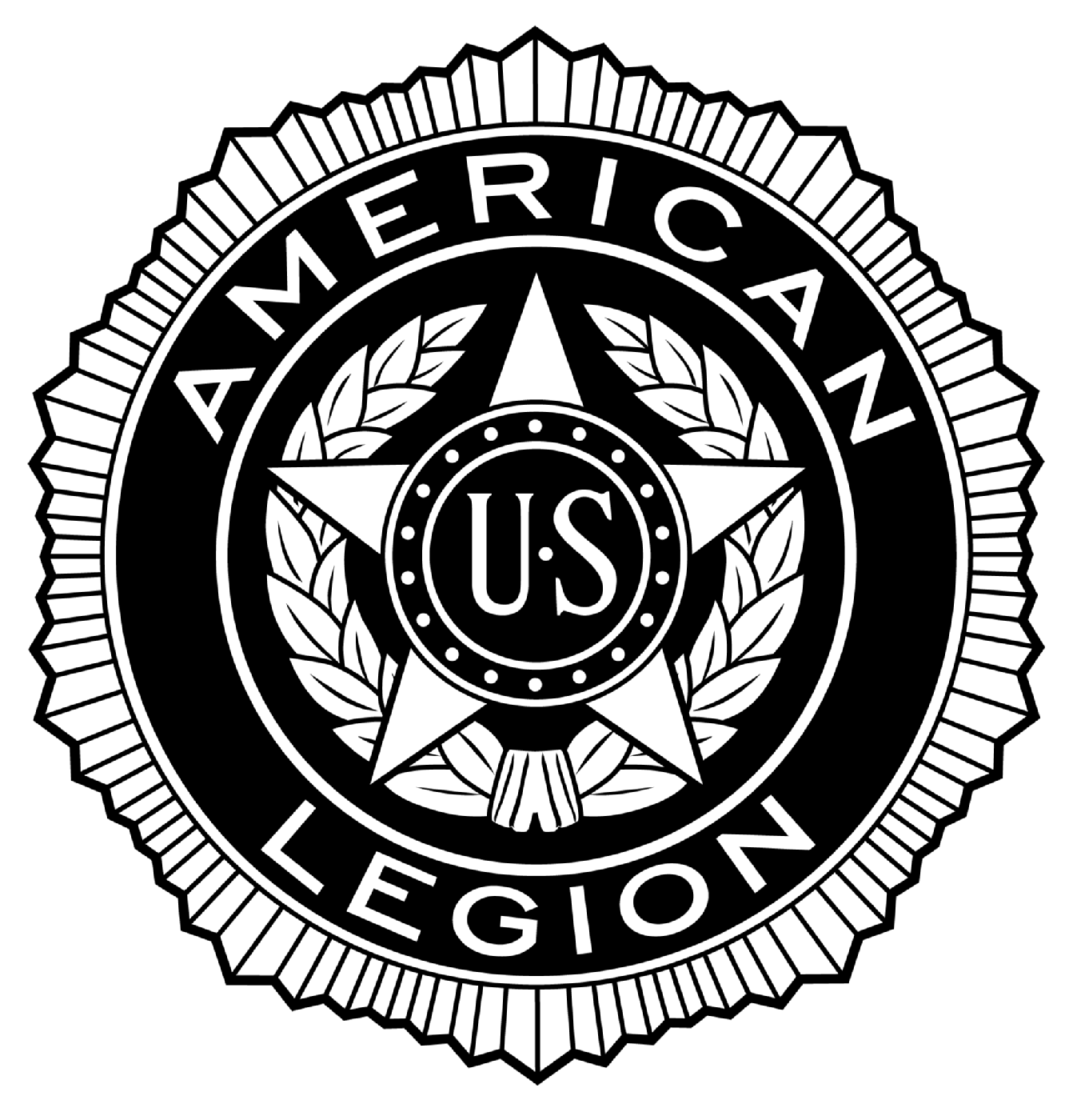
POST #216
Ernest F. Oldenburg, The American Legion
510 West Commerce Road, Milford, MI 48381
www.milfordlegion216.org

Adjutant Notes – Regular General Membership Meeting – Milford POST 216

Commander Cherf called the meeting to order at 19:05 on Tuesday, 16-August-2016.

ROLL CALL OF MEMBERS:
Title | Name | Present | Excused | Absent
Commander | Rich Cherf | X
Senior Vice Commander | Ed Merritt | X
Junior Vice Commander | Gary Dykstra | X
Adjutant | Dennis Dobransky | X
Finance Officer | Ray Williams | X
Chaplain | Tom Kemper | X
Judge Advocate | Tom Neff |  | X
Sergeant-at-Arms | Ron McCall | X
Historian | Norm Tibbs | X
Exec. Committee | John Robinson | X
Exec. Committee | Bill Colegrove | X
Exec. Committee | Joe Bishop |  |  | X
Exec. Committee Aux | Cathy Merritt | X
Exec. Committee SAL | Mike McDonnell |  | X

Guests: Cathy Merritt, Auxiliary President

Approval of Minutes:
Review of Regular Membership meeting minutes from 19 July 2016. Correction: Under Charitable Gaming, change ending check book balance from $1,015 to $1,016. Motion to accept by Schimetz, second by Davison. No discussion. Voice vote passes.
Review of Executive Committee minutes from 2 August 2016. Motion to accept by Schimetz, second by Robinson. No discussion. Voice vote passes.

Reports of Officers:
Commander: Cherf. Advised that the raffle license has been approved and a mass mailing will be issued to the Legion and SAL. Per C. Merritt, the Auxiliary cannot commit to a mass mailing to their members without first asking their membership if they want to partake in this raffle, and this will be an agenda item at their next meeting in September.
Sr. Vice Commander: E. Merritt. Advised Department membership goals have been set for the coming year at 68,507; right now the 3rd zone is in last place for 2017; and Post 216 is at 29.85% paid to date. Also, Ed has application forms that can be carried in a wallet, and he will make about 50 of the forms to be handed out at an upcoming membership meeting. Commander Cherf advised the biggest opportunity to solicit new members is at the Memorial Day parade, and would like to see a recruitment table set up at the Post during the parade day to solicit new members.
(1)
POST #216
Ernest F. Oldenburg, The American Legion
510 West Commerce Road, Milford, MI 48381
www.milfordlegion216.org

Jr. Vice Commander: Dykstra. Advised the Post’s picnic was a big success. Net of expenses, plus donations, 50/50 drawings, and sales of extra supplies, the net cost to the Post was $95. Some extra food was frozen, plus plastic ware, and will be used for future events.
Finance Officer: Williams. For the month ended July 31, 2016, total income was $40,847; Cost of Goods Sold $30,027; Gross Profit $10,820; Expenses $14,853; Net Loss = ($4,033). YTD net income = $4,300. General Fund balance = $24,407; Special (poppy) Fund balance = $10,464. All August bills received to date have been paid. Approved but yet unpaid expenses include: Easter party $200; Donated steak dinners $100; Mass mailing $300; Legion raffle $500; and Membership pins $50. Also, another month of heavy maintenance & repair expenses, plus convention and high school scholarships paid out, our Consolidated Financial Statement YTD is still a positive $4,300. Motion to accept the report subject to future audit by Nevorski, second by Oberg. No discussion. Voice vote passes.
Chaplain: Kemper. Prayers & thoughts for Tom Neff’s wife, Marlene, who is currently in the hospital. Also, our prayers and sympathy go out to the family of Jerry & Kandy Guest for the loss of their 45 year-old daughter due to breast cancer. Also, N. Tibbs advised Robert Fallis underwent a quadruple by-pass surgery, and our prayers for a speedy recovery.
Service Officer: N. Tibbs. No report.
Historian: N. Tibbs. No report.
Adjutant: Dobransky. Read thank you letter from the family of Edward Sopsich for our Honor Guard services at his internment at GLNC. Also, read a thank you letter from South University in Novi for our Color Guard service at their commencement ceremony. Also, read a notice from Haslett Post 269 regarding a 4-day cruise in November, info will be posted in the Club Room.
Auxiliary: Cathy Merritt. Advised a Blood Drive will be held at the Post on Saturday, September 24. Walk-ins will be taken, but those with pre-registration will be taken first. Also, Halloween party will be held on October 22.
SAL: McDonnell. Excused. Commander Cherf advised of the upcoming golf outing on August 21, with proceeds going to the Wilwin Lodge.

Committee Reports:
Membership: Kotas. New Member: Thomas w. Underhill, Army, Vietnam. Motion by Kotas to accept the new member, second by Robinson. No discussion. Voice vote passes.
Also, as of August 16, we are at 42% membership renewals (172 members) for 2017, based on the Department target of 50% by September 7. We are the 2nd largest Post in District 18, behind only the Royal Oak Post. Also, he did issue the area-veteran mass mailing to solicit transfers from Lansing, and has had (2) positive responses to date.
Color Guard: Robinson. On August 27, the Color Guard will be attending a Detroit Red Wing alumni charity softball game. Attended an event on July 12 in Detroit honoring veterans, and the VA requested Post 216 to do the closing Color Guard ceremony, this being a high honor for our Post.
Honor Guard: Robinson for Chowaniec. Advised (8) internments were held this past month at Great Lakes National Cemetery, plus (1) local internment.
(2)
POST #216
Ernest F. Oldenburg, The American Legion
510 West Commerce Road, Milford, MI 48381
www.milfordlegion216.org

Poppy: N. Tibbs. Be on the watch for a scammer that is hitting local Posts for money.
Honor Walk: Dykstra. One new brick is in the works.
Memorial Day Parade: Salvia. Absent. No report.
Education and Scholarship: Davison. No report.
Boys State: E. Merritt. Plans to have the boys that attended this past June present at our October meeting to provide a presentation of their experience at Boys State. Will also be going to Lakeland High School to do an award presentation.
Bingo: Dobransky for McDonnell. July 2016: Gross Bingo $11,067; Gross tickets $16,552; Ticket Prizes $12,558; Bingo Prizes $8,180; Gross Profit $6,409; Deposit tickets $3,994; Deposit Bingo $2,396. Beginning check book balance $1,430. Ending check book balance $1,808. Bingo turned over a check to the Legion for $2,800. Motion to accept pending any corrections by Colegrove; second by Schimetz. No discussion. Voice Vote passes.
Club Room: Dobransky for McDonnell. July 2016: Gross Income $8,464. Cost of Goods Sold $2,490; Gross Profit $5,974; Expenses $4,563. Net Income = $1,411. Motion to accept pending any corrections by Lloyd, second by Colegrove. No discussion. Voice Vote passes.
Charitable Gaming Tickets: Dobransky for McDonnell. July 2016: Beginning check book balance $1,016. Ending check book balance $407. Charitable gaming turned over a check to the Legion for $1,000. Motion to accept pending any corrections by Colegrove, second by Oberg. No discussion. Voice Vote passes.
American Legion Riders: McCall. The Riders have been active doing various rides. The Riders are in the process of setting up an Octoberfest party at the Post, to include German beer and food. Commander Cherf advises the Riders have accumulated to date $6,545 to be applied toward the bathroom remodeling cost.
House & Building: N. Tibbs. Advised the masonry work on the outside of the building is 99.9% completed, and the fire place has been inspected and is good to use. The root killer he placed down the drain appears to be working, as all is dry. A fused disconnect on the A/C unit has been installed, and this will help prevent surge damage to the unit.
Advises the roof over the dome needs re-caulking due to some cracking. Cost estimate is about $1,300. Commander Cherf advised the SAL had mentioned they would assist with the cost, but we need to approach the SAL again to confirm their commitment. However, there is concern that we will run out of good weather to do the repair. Motion by Colegrove to allow up to $2,000 to do the roof repair, second by Lloyd. Discussion: We should solicit more than one bid for the roof repair. We will still pursue the SAL subsequent to the roof repair. No further discussion. Voice vote passes.
Advises the masonry work still needs to be painted. A bid obtained is $3,350 labor, plus cost of the paint. Commander Cherf advised he did a walk-around, and some of the lower stucco work needs patching. The new masonry work needs to be primed at least, and final painting can be done in the spring. It was decided Post volunteers would do the painting. Motion by Tibbs to allow up to $500 to purchase the paint, second by Colegrove. Discussion: We can purchase an all in one primer & paint mixture; Ron Nevorski will price out the cost. No further discussion. Voice vote passes.

(3)
POST #216
Ernest F. Oldenburg, The American Legion
510 West Commerce Road, Milford, MI 48381
www.milfordlegion216.org

Scouts: Commander Cherf for Chris Cook. Reports that the scouts are about $1,200 short of the $2,800 needed to build the on-site storage shed. A possible donation of some of the materials by Lowes is being pursued. Possible popcorn sales may help with the cost. It’s possible that each organization within the Post can contribute up to $300 to help the scouts reach the $1,200 needed.
N. Tibbs makes a motion to set aside $300 should the scouts fall short of the $1,200 needed, we can cover the last $300, second by Colegrove. General discussion ensued. Voice vote passes.
Old Business: Commander Cherf advised the raffle is on hold until he gets mailing list from SAL, and hopefully from the Auxiliary. Canon repairs – steel has been ordered and materials should come in next week. The tank decals will be replaced weather permitting. Also, look for upcoming Riders fundraisers at the Post, such as a chili cook off, spaghetti dinner, and Euchre tournaments.
New Business: Robinson made a motion to order up to $170 in uniform related supplies for the Honor Guard, second by Lloyd. Discussion: The order would be placed with Flag & Emblem Sales. No further discussion. Voice vote passes.
A lady in the community has offered up free haircuts at the Post, once a month, with the first time being August 31. There is a sign-up sheet posted in the Club Room.
Robinson advises that on September 12 at noon, there will be a Vietnam era veterans’ luncheon held at Mystic Creek club house in Camp Dearborn at no cost to the veterans.
Good of the Legion: Nothing to report.

Closing: Commander Cherf: There being no further business to come before the membership the meeting was adjourned at 20:35, with the proper closing ceremonies being observed.

The next meeting is 20 September, 2016, 19:00.

Prepared and submitted by: Dennis Dobransky, Adjutant

(4)
POST #216
Ernest F. Oldenburg, The American Legion
510 West Commerce Road, Milford, MI 48381
www.milfordlegion216.org

ROLLING MINUTES (Used to capture significant agreements and/or votes of a permanent nature unless later eliminated or changed by membership or the Executive Committee as is allowed). This document will form a part of each monthly meeting minutes to be used for quick reference as may be needed.

- The Post Commander is granted $250 in discretionary expense spending per transaction. (From June 16, 2015, General Membership meeting minutes).

- Emergency expense funding, such as the breakdown of the building furnace or A/C unit. As long as the Club Room manager, or the building chairperson, contact the board to advise of the emergency situation, then the emergency funding will be authorized. This is different than say the cost to resurface the parking lot, which is not an emergency situation that would be presented to General Membership for review and approval. (From June 16, 2015, General Membership meeting minutes).

- A policy has been implemented that any person that financially obligates the Post for non-emergency related expenses, aside from the Commander’s $250 discretionary expense authorization, without the prior consent of the general membership, can be held personally liable for the expense. (From July 14, 2015, Executive Committee meeting minutes).

- The Executive Board decided the start date for new officers will assume office at the 1st Executive Board meeting following the election process. This will allow the incoming officers to coordinate with the departing officers the passing of the office. (From June 14, 2016, Executive Committee meeting minutes).

- The Executive Board decided in regards to the election vote process, tie breakers will be determined by a re-vote of present members, and the Post Commander will not cast a vote. (From June 14, 2016, Executive Committee meeting minutes).

- General membership voted to allow a listing of Legion member names in local publications designed to honor them for their service to our country, during such times as Memorial day and the 4th of July holidays. (From June 21, 2016, General Membership meeting minutes).

(1)

